**ACCOUNTS PAYABLE:--K\***

* AP will contain all the vendor related information which can be a creation vendor master data,vendorpurchase, vendor payment, down payment and credit memo etc.
* AP is nothing but **purchase to pay** or Procure to Pay as per business process.
* Account type is K which was mentioned in T.code-OB52

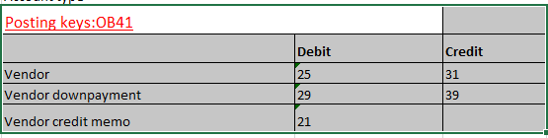

* 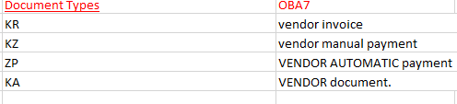

**CONFIGURATION STEPS:**

**1).Define Account Groups with Screen Layout (Vendors) T.code-OBD3.**

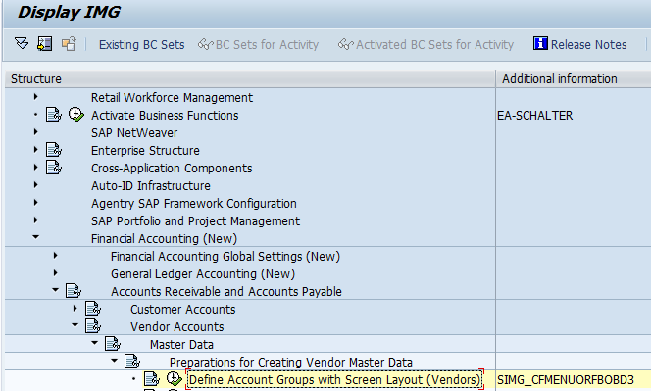

NOTE:

1. Vendor groups can be a purchase group, without purchase group, one- time vendor, localvendor, foreign vendor and Employees etc.
2. Each vendor groups are having 3 segments or Vendor—**Interview question.**

A).General Data segment Table name LFA1.Example: Address-- Which is created at client level. (Postal code, city and country).

B).Co.code data segment Table name-LFB1--Example--Reconciliation account, sort key etc. Created at company code level.

C). Purchasing Data Table name-EKKN--Example--Purchase order currency, terms payment.

2).**Create Number Ranges for Vendor AccountsT.code-XKN1.**

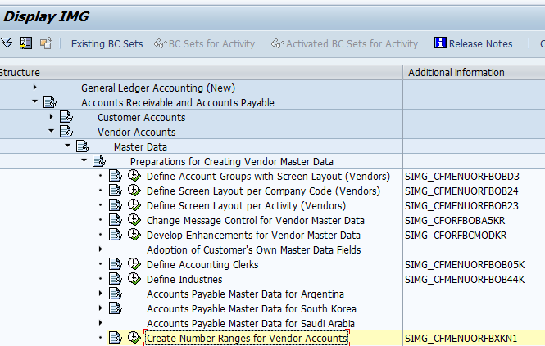

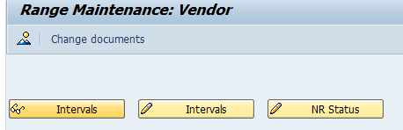

Note:

The FI number ranges which are maintained at fiscal year wise and vendor/customer/asset numbers ranges which does not having fiscal year.

3).**Assign Number Ranges to Vendor Account GroupsT.code-OBAS.**

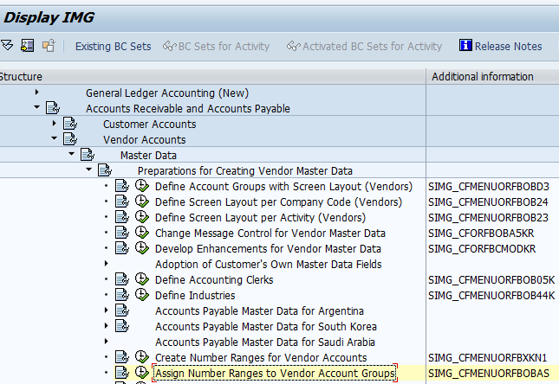

Note:

* Vendor groups which are assigned to number ranges, hence at the time of creation of the vendor master data, system will generate the vendor account number from this number range only.

**ENDUSER ACTIVTIES:**

* Creation of Recon.GL account: T.code-FS00.1000006
* Creation of the vendor master Data T.code-XK01 OR FK01

|  |  |  |
| --- | --- | --- |
| Creation of the vendor | XK01 | FK01 |
| Change of the vendor | XK02 | FK02 |
| Display of the vendor | XK03 | FK03 |

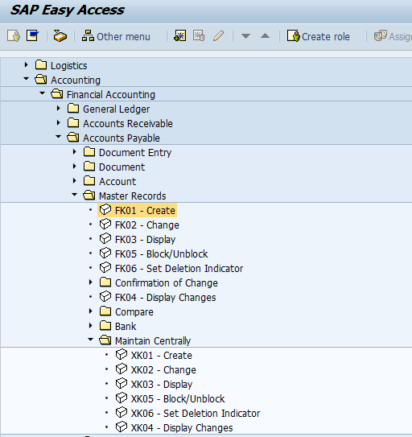

* X Means creation of the vendor with purchase organization.
* F means creation of the vendor without purchase organization.

1. Vendor invoice posting:T.code- FB60/F-43/MIRO.

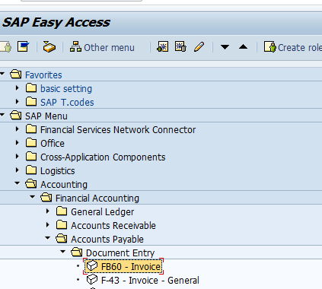

Note:

* Vendor invoice has been divided into two categories.

1. Vendor normal invoice (Without purchase orders) T.code-F-43 and FB60.

Example- Expenses posting (Admin, marketing etc..)

**Accounting entry**: Expenses Account DR-40

Vendor Account CR-----31.

1. Vendor invoice with purchase order T.code-MIRO.

**Accounting entry:**GR/IR clearing Account DR-86

Vendor Account CR-------31.

**Display/Change Line Items** T.code-FBL1N.

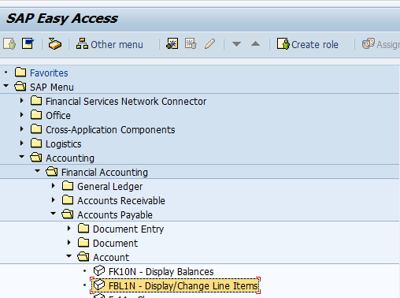

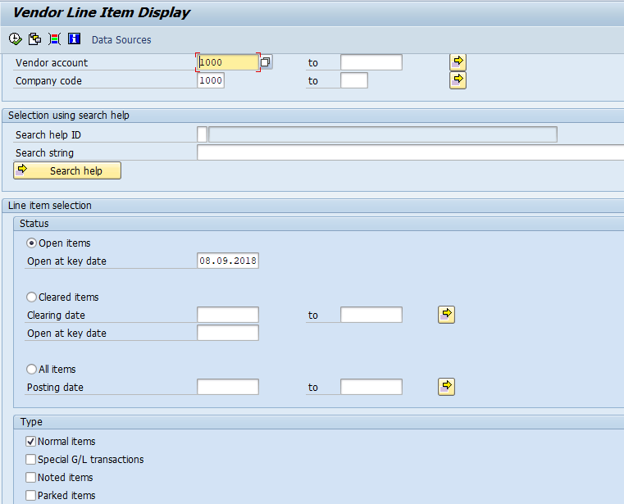

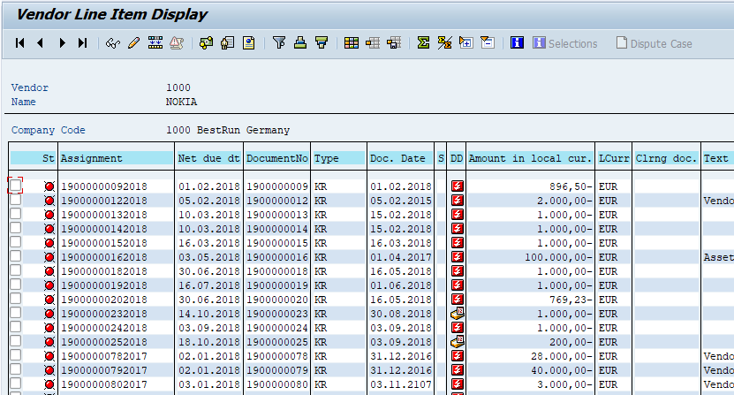

WHAT IS THE PURPOSE OF THE NORMAL ITEMS/SPECIAL GL transactions/ NOTED ITEMS/PARKED ITEMS AND CUSTOMERS?---**Interview question**.

1).**Normal items:**

* All invoices which were posted through T.code-FB60/F-43/MIRO Which will come under normal items.

2). **Special GL transaction**:

* Is nothing but down payment T.code F110/F-54 ( Down payment clearing) which will be displayed under this type.

3).**Noted items:**

* Down payment request T.code F-47 Which will be posted under this type.

4).**Parked documents:**

* Vendor invoice documents which can be parked, thosedocuments which will be displayed under this type.

5). **Customer items:**

* If vendor is customer and customer is vendor which will be posted under this type.

**CREATION OF THE HOUSE BANK.**

* House bank is nothing but a bank which we can do on daily transactions.
* Example- Outgoing payments and Incoming payments.
* Each House bank is having three type of GL as mentioned below.
* **Main Bank GL:**.
* Creation of the GL account done by the business in production system.
* Which is assigned to House Bank T.code-FI12.
* End of the Day Bank GL incoming and Bank outgoing GL transaction which will be transferred to main bank GL account through T.code FF_5 (Automatic Bank Reconciliation)
* This T.code which is executed by the business in the production system.

2). **Bank Outgoing GL**

* Creation of the GL account done by the business in production system.
* This GL account which is assigned to T.code-FBZP/Bank Determination/Bank account.
* Vendor payment can be done with this GL only.

3). **Bank incoming GL.**

* Creation of the GL account done by the business in production system.
* This GL account which is assigned to incoming payment method/ FBZP/Bank determination/Bank account

**Vendor Payment Process:**

* Vendor payment which can be done by 2 ways.

1. Manual payment which is posted by T.code-F-53.
2. Automatic payment which is posted by T.code-F110.

Note:

* In company, all the payments which are related to automatic only and no manual payments are involved in company.
* Automatic payments which is always link to your bank through IDOC and DMEE.
* Manual payment which is not link to bank ( IDOC or DMEE is not generate for manual payments).
* Accounting entry is the same for both T.codes.
* In Development and test/quality system, consultant will use T.code-F-53/F-48 which is very easy for posting of these T.codes.

**Vendor Manual Payment T.code-F-53**

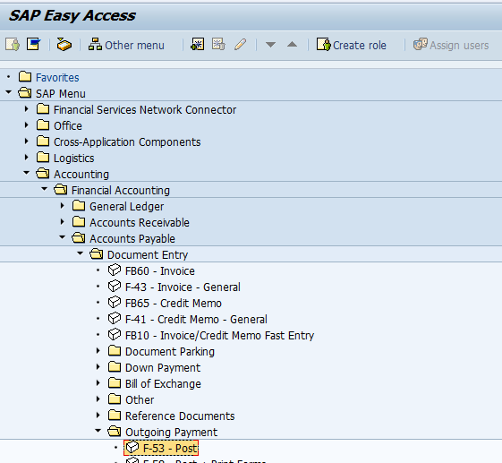

**What is the Accounting entry for manual or Automatic—Interview question.**

Vendor Account DR-25

Bank Outgoing GL-CR-50

**Creation of the Bank key:**

T.code-FI01,02 and 03

* Creation of the bank key is done by the business in the production system.
* Creation of the Bank key is done by the consultant in the development and test system with reference to production system details.

**What is the purpose of the Bank key—Interview question.**

* Bank key is created at country level.
* To identify the bank address details (Bank name, Street and city etc..)

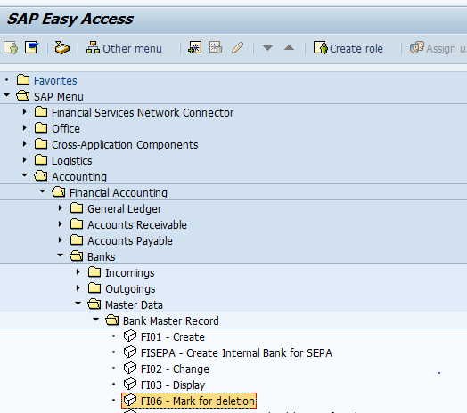

**What is the purpose of the swift code and IFSC code?-Interview question.**

* Swift code is used for internationals payment.
* vendor is located in US, to make the payment for foreign vendor, we need a swift code which need to be entered in the bank key.

**IFSC code:**

* For domestic payment we need a IFSC code which is not available in bank key master data.
* IFSC code field is not available in the bank key master data.
* Bank key is mapped as a IFSC code as per SAP standard.

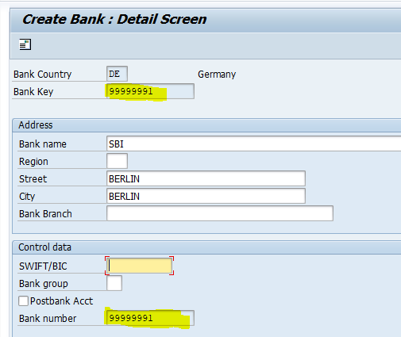

* In development/test system bank key created by consultant with reference to production system data.
* In production system bank key is created by business.

**Creation of the House Bank T.code-FI12**

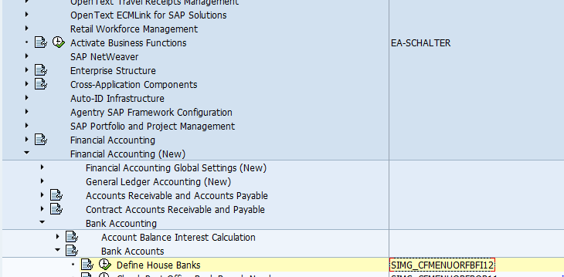

* Tables-T012 which is having house bank/account id/country.
* T012k- which is having Bank account number and GL account.
* House bank cannot be created without co.code.

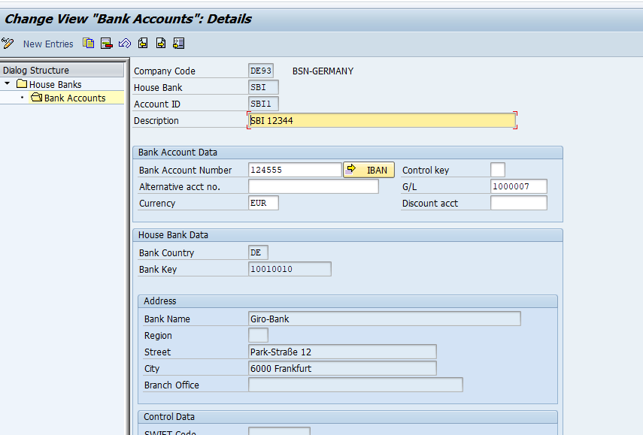

**Automatic Payment program:**

* Now a days all the payments are automatic payments which means bank is making the payment on behalf of the vendor, for this we need to configure Automatic payment Program.
* FBZP - is the configuration for F110 automatic Payment run (Enduser T.code).
* Which is having 6 steps:

1).**All company codes :**

* Customer and vendor Special G/L transaction to be processed.
* Paying co.code is need to be specified to make the payment to vendor, if paying co.code is blank, system will treated sending co.code as a Paying co.code and will make the payment by using T.code-F110.
* 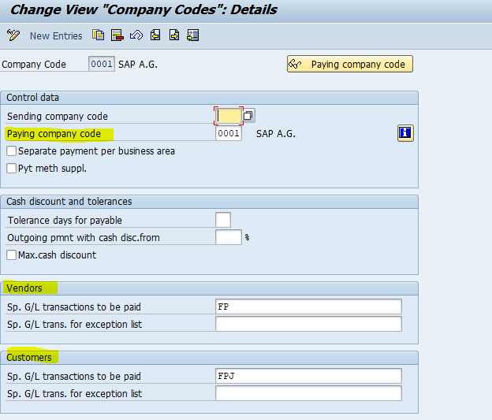
* 2).
* Minimum amount for incoming and outgoing payment 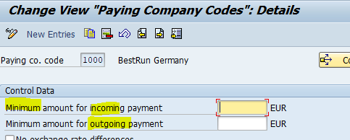

**3).**

* Payment methods which are created at country level.
* Example- B- Demand Draft, C-Check, D- SBI DD- N-NEFT, R-RTGS- etc..
* Document type is used to payment method.-ZP

4).

* Payment methods which are created at country level and assigned it to co. Codes.

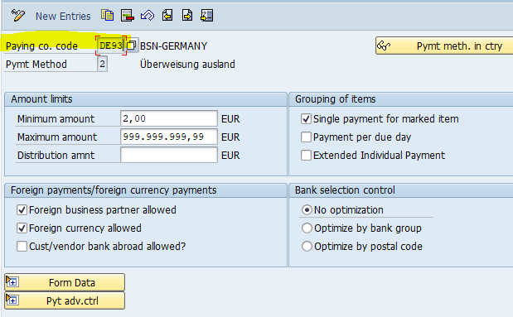

To make the payment for foreign vendor, we need to select foreign vendors three check box which are available in this step.

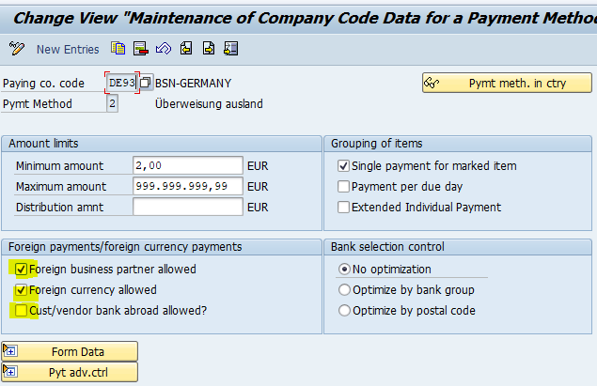

5. **Bank determination** 

A. **Ranking ORDER**—The order in which payments will be processed against the bank.

Example HSBC 1

CITI 2

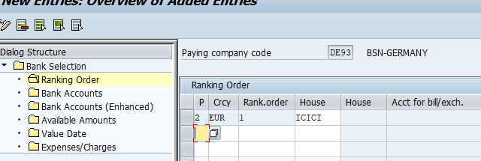

B. **Bank Accounts (Enhanced.**

Bank accounting GL and incoming GL which are assigned here.

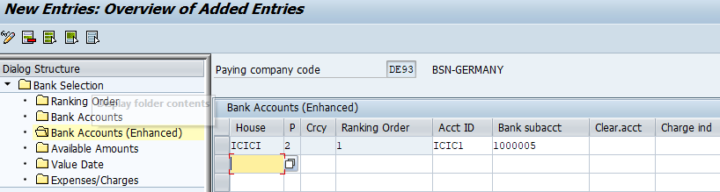

c. Available Amounts—

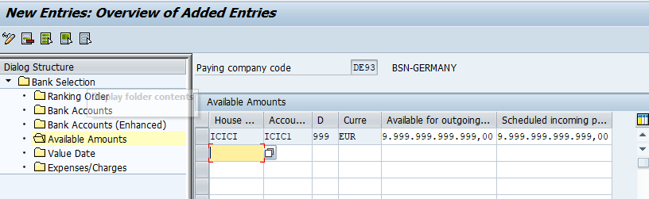

**What is the purpose of 999?**

The following specified amounts are only planned for payments where the value date on the bank account is expected within the number of days given here.

Use

Using the value dates, you can plan amounts on a time scale. As a rule, you only need this if you have bill of exchange payments to be posted before their due date. In all other cases, you can enter 999 and then the value dates will not be taken into consideration.

**ENDUSER CYCLE FOR AUTOMATIC PAYMENT RUN**

1. Vendor invoice posting T.code-F-43/FB60/MIRO.

**Pre-requisites for F110**

1.Payment method and vendor bank details is assigned to vendor master data (FK02) and vendor open item should be overdueT.code-FBL1N.

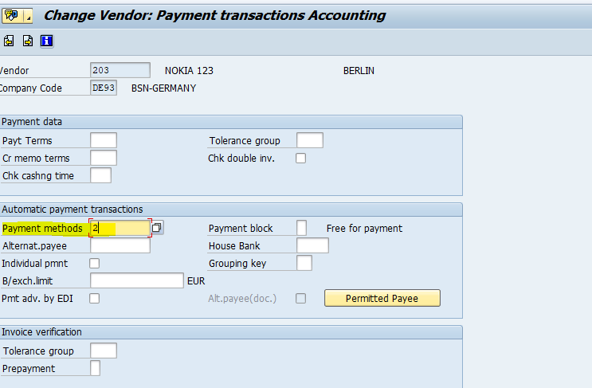

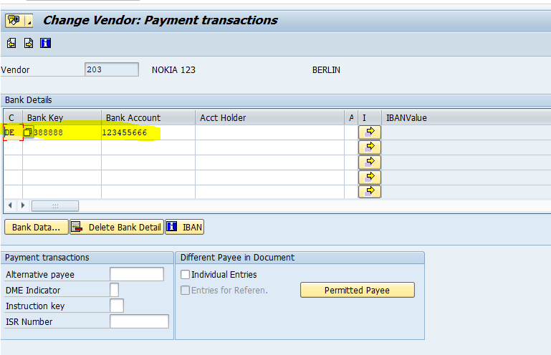

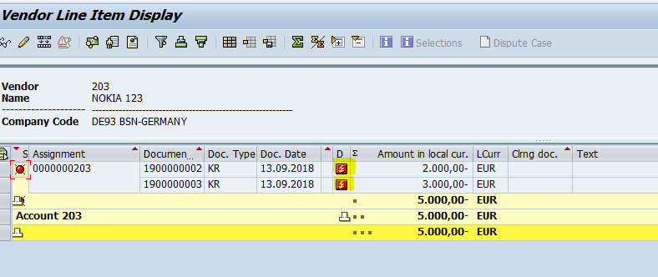

1. Execution of the F110.

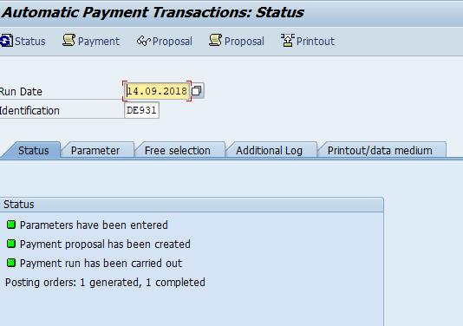

**What is the purpose of the next payment run date in F110?-Interview question**

* Next payment run date is nothing but net due date of the invoices which are overdue, system will considered all those line items of the documents in the payment run.
* 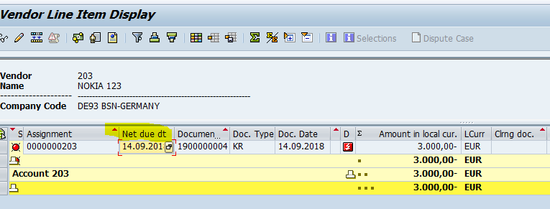
* Example- T.code-FBL1N- Open line items which need to be overdue.

**IDOC.**

* IDOC meaning Intermediate document between two systems Example- SAP to non-SAP system vice versa or SAP to SAP systems through EDI system (Electronic data interface).
* IDOCs are created through message types (EUPEXR). IDOCs consist of three components.
* (1) control record, (2) data segments, and (3) status records.

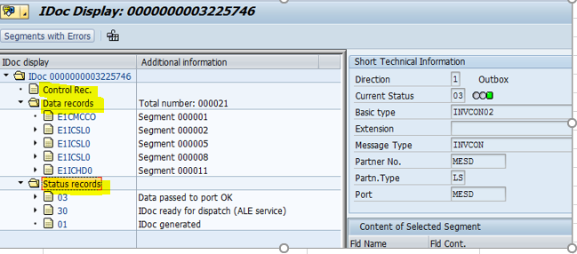

**IDOC configuration steps:**

* SAP has provided two configuration steps for IDOC generation as mentioned below.

1 EDI partner number and payment methods should be maintained in T. code-FI12 (House bank creation) -- TR will be generated.

2.Partner profile should be maintained T.code-WE20--- TR will not be generated.

**Note:**

Thisactivity(WE20) can be maintained on each system separately.

**VENDOR AUTOMATIC PAYMENT PROCESS.**

1. Vendor invoice posting T.code-F-43/FB60 and MIRO.
2. Vendor open items which need to be overdue-FBL1N.
3. Execution of the F110 (Automatic payment run).

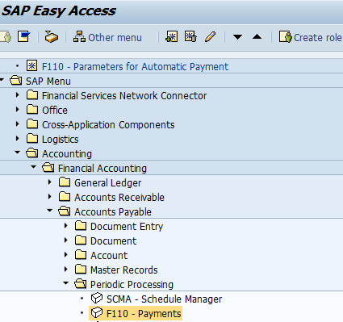

**Note:**

* Before execution of the F110, we need to ensure below steps should be checked.

1.Payment methods should be assigned to vendor master--XK02

2.Vendor open items should be overdue-FBL1N.



**PAYMENT PROCESS:**

Payment process can be divided into two parts.

1**.Outbound interface** is nothing but from SAP to Bank which can be called as an outbound interface. Example- ISOXML20022.

**Process flow:**

SAP-----------🡪IDOC--- SAP XI (PI)-----------🡪 SAP Bank system (SAP PI).

HTTPS connection between two systems.

* IDOC is get converted into **ISOXML20022** format which is a universal format for banks.

2**.Inbound** interface from Bank to SAP process is called an bound interface Example-MT940 and UTR.

**Process flow:**

SAP Bank system-----------🡪 SAP XI (PI)-------------------SAP ECC (T.code-FF_5)

MT940 and UTR.

**MT940:**

* MT940 is the bank statement which bank sent every day to SAP to reconcile bank books and SAP Books.
* This statmenet can be viewd in T.code-FEBA
* MT940 is a txt format.

**UTR:**

* UTR means unique transaction reference number which can be a DD number, check number or electronic system generate code (Reference number).
* UTR number will be updated in payment document in reference number.

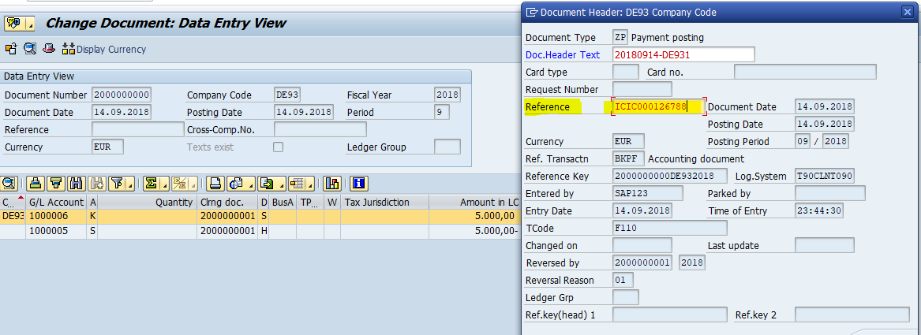

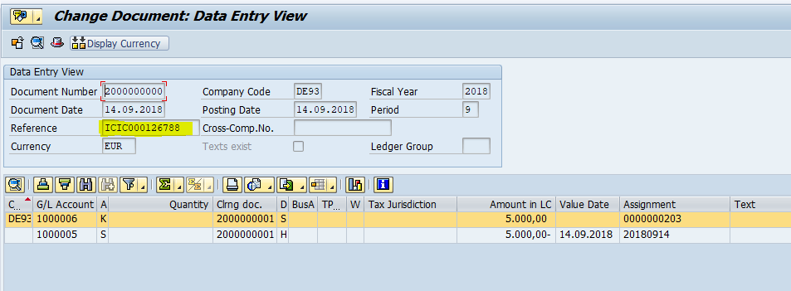

**Payment advice:**

* After making payment to the vendor or employee, bank will send payment advice (PDF document) which contain vendor code (203), amount, date, bank account number.
* Payment advice can be viewed T.code-SP01.
* Bank is sending to the payment advice by email which was maintained in the vendor master data.

**DOWNPAYMENT PROCESS.**

* Down payment is nothing but advance payment to the vendor.
* Down payment is SAP terminology
* Advance payment is normal terminology.

|  |  |
| --- | --- |
| Example: |  |
| Company code | DE93 |
| Vendor | 203-Nokia |
| Requirement | 2000 New android mobile |

**Configuration steps for vendor down payments:**

1.Define Alternative Reconciliation Account for Down Payments T.code-OBYR.

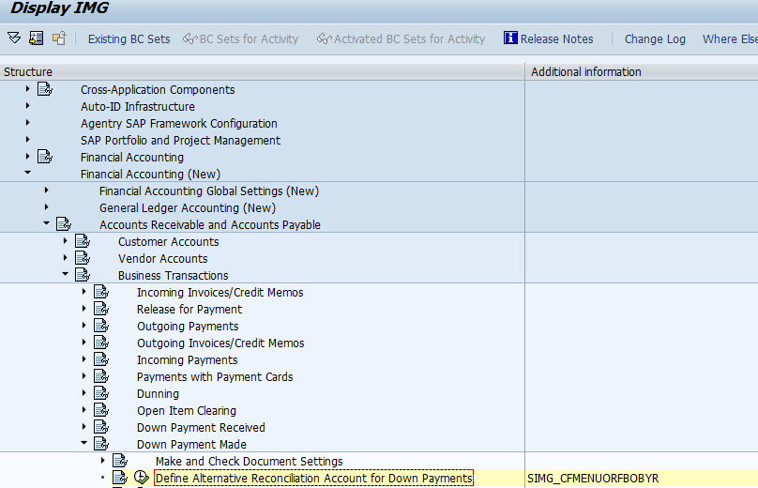

* Special GL indicator is nothing but down payment indicators.
* Down payments can be mapped with Alternative reconciliation GL accounts (Special GL accounts)
* Reconciliation Gl is assigned to vendor master (XK02/FK02).
* **Special GL indicator (Down payment).**

**Indicators.**

* A Down payment on current assets
* B Financial assets down payment
* F Down payment request

**DOWNPAYMENT ENDUSER PROCESS:**

**Down payment Cycle or Process:**

1 Creation of the Down payment Request:

T.code F-47

Accounting Entry:

39F vendor special GL credit.

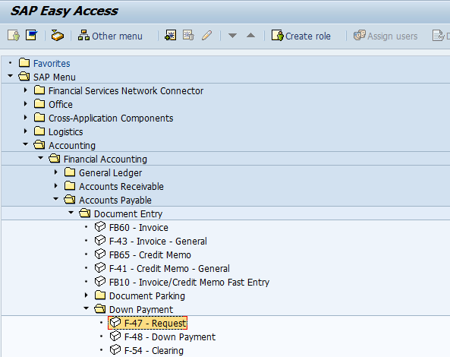

**Note:**

* Each document is having debit and credit, but down payment request is having single line item which is called as a noted item (FBL1N).
* Noted item is nothing but a down payment request**.**

**2).** Vendor open items T.code-FBL1N- Select noted item check box

3).Vendor down payment T.code-F110

Accounting Entry : vendor special GL DR-29 and Bank outgoing GL CR-50

4) Vendor invoice posting T.code F-43/FB60/MIRO

4). Vendor down payment clearing T.code F-54.

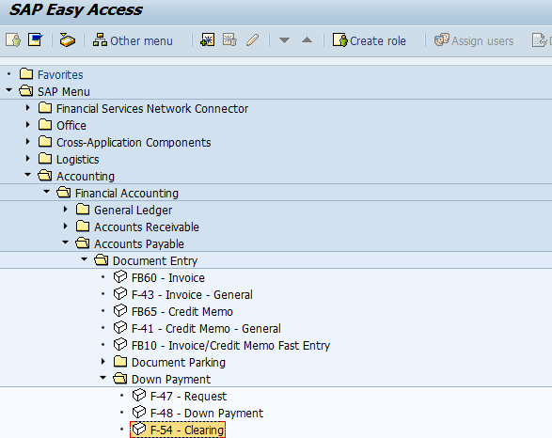

5). VENDOR OPEN ITEM KNOCKING-OFF

T.code F-44

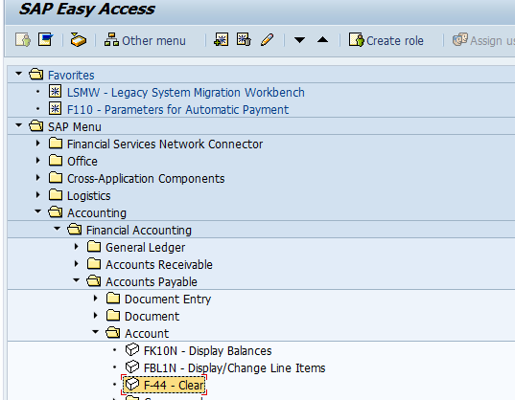

**Summary:**

1 Configuration step---OBYR

**Enduser cycle.**

1 Down payment request F-47

2 Down payment F110

3 Vendor invoices posting F-43 OR FB60

4 vendor downpayment clearing F-54

5 vendor open item knock-off or clearing F-44

**PARKING documents for GL/AP/AR.**

* Each T.code is having parking document option.
* SAP has also provided seprated T.code for parking document example-FV60 for vendor invoice.
* Parking can be done by user does not have authorization to post a document in production system.
* User does not have full information about the posting document (Amount, cost centre)
* Parking document can be deleted.
* At the time of parking and posting system will be used same document number.

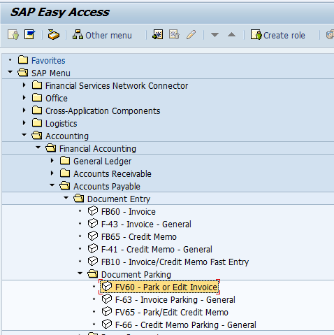

Post /delete.

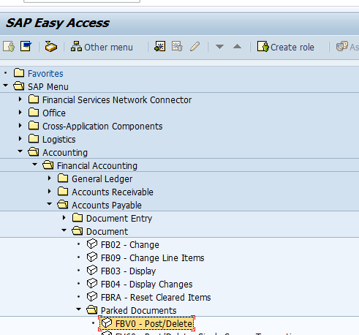

**HOLD OR HELD DOCUMENTS:**

* Each T.code is having held or Hold option Example: F-02,FB50,FB60 ETC.
* At the time of held or hold system will ask to enter temporary document number.
* Which can be entered as a Alpha and Numeric (ABC122)
* At the time of posting held document, system will generate the document number from number range.
* Held documents can be deleted.
* There is no separateT.code for held.

* To get the held document list by using T.code F-02/ select held.
* 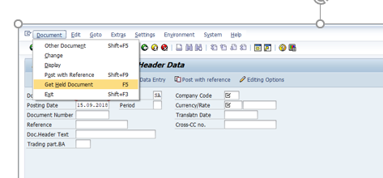

PAYMENT TERMS:

* Terms of Payment are conditions agreed between business partners (Vendor/customer) for the payment of invoices.
* The conditions define the due date and the cash discount offered for payment of the invoice within a certain period.
* Terms of payment enable the system to calculate a cash discount and invoice due date.
* Terms of payment is maintained in vendor master and customer master to default at invoice level however this can be changed at invoice level as well.

**Creation of the payment term : T.code-OBB8.**

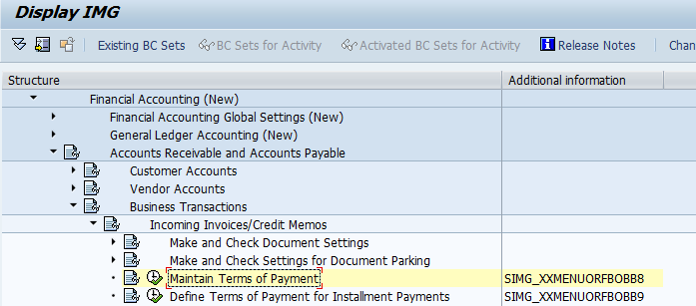

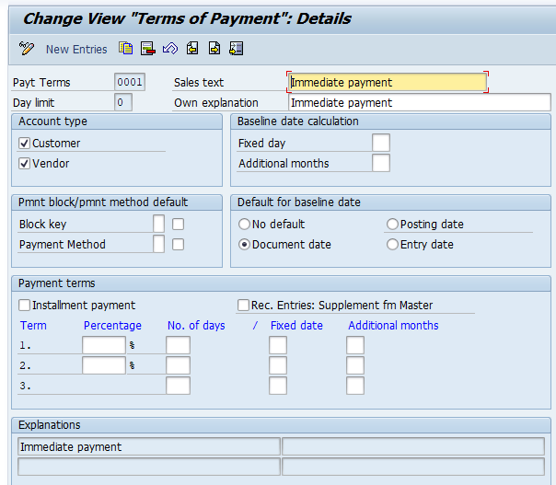

**What is the purpose of the day limit?-Interview question.**

**Scenario- 1 – Payment Term T001**

**Day Limit   – 20**

**Discount – 5 %**

As per above details system will consider this payment terms for the invoices posted in system ON or BEFORE 20th date in every month and applies 5% cash discount. The discount won’t be applicable for invoices posted after 20th in month.

**Scenario- 2 – Payment Term T001**

**Day Limit   – 31**

**Discount – 2 %**

As per above details system will consider the invoices for 21st to 31st and applies the 2% discount.

This perfectly suits where the requirement is – the invoices posted upto 20th should have 5% discount and invoices posted in date range of 21st to 31st should apply discount of 2***%.***

**Account Type –**

Customer: If payment term is intended to use for “Customer” please select this check box.

Vendor: If payment term is intended to use for “Vendor” please select this check box.

**Baseline Date Calculation –**

* **Fixed day:**This field signifies the “calendar fix day” for base line date calculation.
* **Additional Months:**Value maintained here is used to add the calendar month for base line date calculation.
* **See below example –**
* 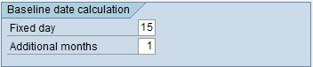
* In above case the base line date would be 15th of the next month.

**Pmnt block/pmnt method default –**

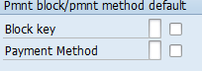

1. Block Key: The value maintained in this field signifies the block key for payment.
2. If block key is maintained here the system proposes the block key along with terms of payment.

**Payment Method**: If user wants to maintain the payment method here other than customer/vendor master it can be maintained here as an identifier.

**Default for baseline date** –

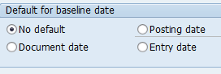

1. **No Default**: Selecting “No Default” here means system prompts user to enter baseline date as own.
2. **Posting date**: Selecting this means posting date mentioned will be same as “Baseline Date”.
3. **Document date**: Selecting this means document date mentioned will be same as “Baseline Date”.
4. **Entry date**: Selecting this means “Systems Date” will be same as “Baseline Date.

**Payment terms**

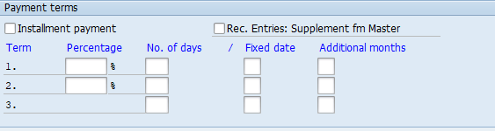

**Instalment payment (EMI):**

1. Check this field if user wants to break down the invoice line items with different due dates.
2. Use the instalment payment term functionality to achieve this.

**Recurring Entries: Supplement fm Master:**

1. Selecting this indicator means, for recurring entries the payment is term is fetched from master record if does not found in line item.

**Percentage:** The percentage rate which will be used to calculate the discount.

**No. of days**:

1.Maintain the number of days for the discount rate is valid.

1. Like if payment received within 10 days 3% discount will be granted. So maintain the 3% in percentage field and 10 days in “No. of days” field.

**Fixed date**:

1.This field is used to determine the fix day of the calendar month as due date.

**Additional months**:

1.Enter the value here if you want to add the months to fix day.

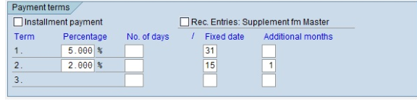

In above example –

1.5% discount will be granted in the same month.

2.2% discount will be granted if payment performed before 15th of next month

3.Full payment is due after this.

**Creation of the instalment payment term:**

**T.code-OBB8**



**Note:**

1.Instalment payment term :0017

2.Main payment term : 0001

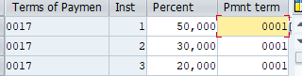

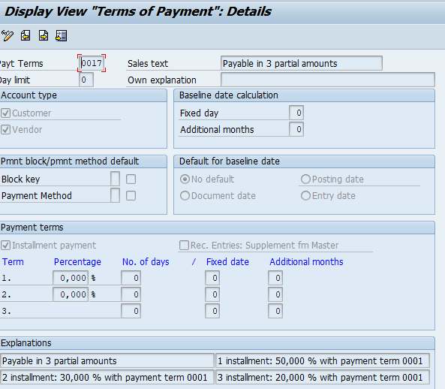

**Main payment term**

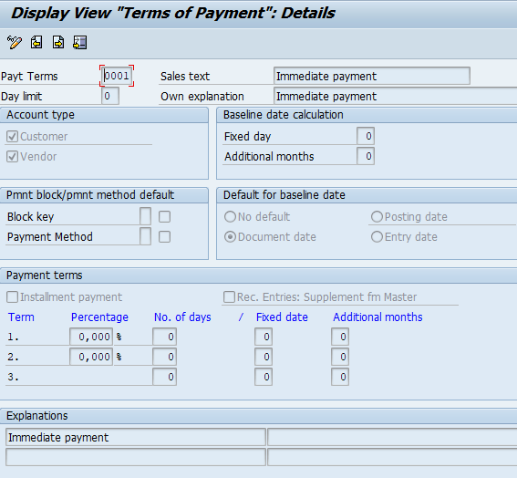

**Test scenario.**

1 Payment term is assigned to vendor master. XK02/FK02.

2 Post the vendor invoice F-43/FB60/MIRO

3 Vendor open items FBL1N

**ACCURAL/DEFERRAL:**

**1.** Accrual means expenses which are occurring in current month, but paying to next month.

Example: Salaries and rent expenses.

2.Aug 2018 rent to be paid on 1st of September 2018. These expenses are showing as a expenses in the P& L account by the companies for the month of Aug 2018.

3. 1st Sep 2018, these accrual/deferral documents which was reversed and posting actual expenses/income.

4. Deferral means income Example- Interest received from bank. But these interests are related to previous month.

5. There is no configuration for this activity.

**Test scenario:**

1). Creation of the GL account- Rent or salaries or interest received.

2)FBS1—1900000012— 1900000013-fbl1n

3) F.81

ENTER ACURAL/DEFFERAL POSTING T.CODE-FBS1.

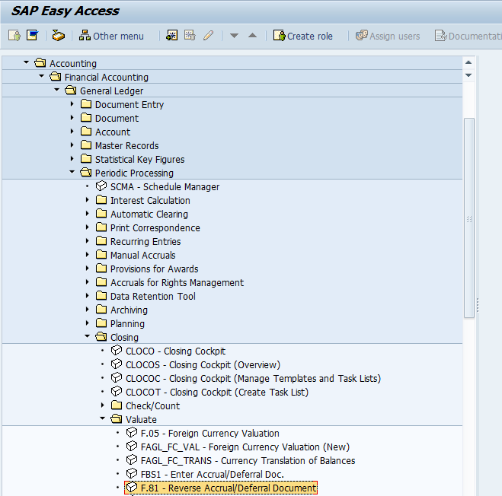

F.81 - Reverse Accrual/Deferral Document

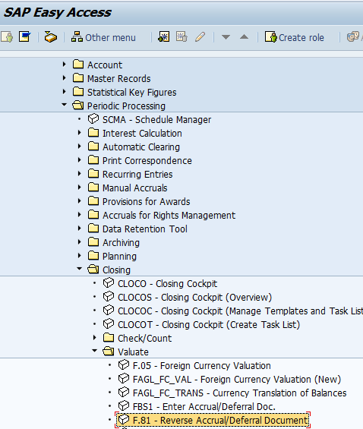

**REVERSAL PROCESS:**

* Reversal can be done by business, if something is entered wrongly at the time of posting of the document T.code F-02,F-43, FB60 etc..
* Example-Amount, GL account etc..
* SAP has provided different types of reversal.

1). **Individual Reversal.**

T.code FB08.

Note: To reverse only one single document which is a open item by using FB08.

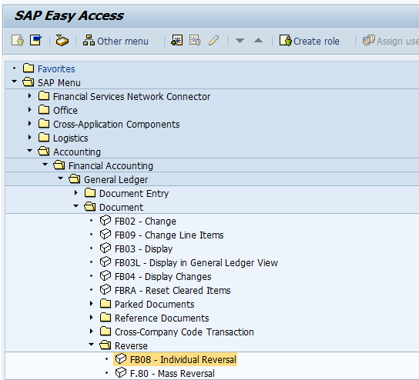

**Test scenario-**

* 1. FBL1N/FBL3N/FBL5N- document should be as a open item.
  2. FB08

2).Mass Reversal

T.code F.80

Note :To reverse a document more than one open item document which can be possible by using T.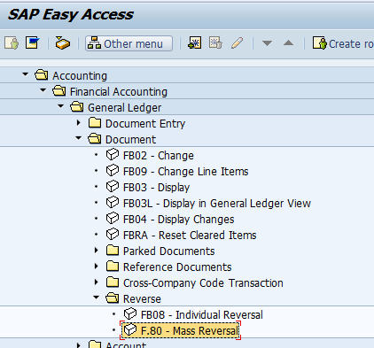

**Test scenario-**

* 1. FBL1N- document should be as a open item.
  2. F.80

3). **Cleared item Reversal**

T. code FBRA.

Note: Cleared documents also can be revered by using this T.code (FBRA) and only single cleared item document.

**Test scenario-**

1. Execution of the FBL3N/FBL1N/FBL5N ,cleared item tab,
2. Take clearing document enter T.code-FBRA.

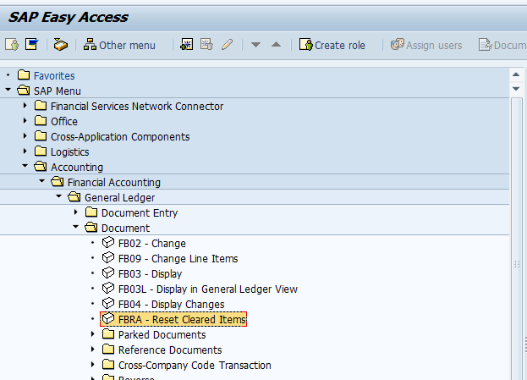

4). Accrual/ Deferral Reversal T.code-F.81.

5). Purchase order Invoice document reversal T.code-MR8M-FI-MM

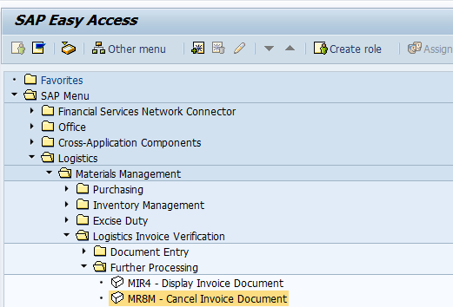

6). Goods Receipt cancellation T.code-MIGO ( FI-MM).

**RECURRING DOCUMENTS:**

1. Periodically recurring entries posted by the recurring entries program based on recurring entry documents.

2.This process is comparable to the standing order you give to your bank to deduct your rent, premium payments, or loan repayments.

3.Recurring entries are business transactions that are repeated regularly, such as rent or insurance

4.The following data never changes in recurring entries:

Posting key

Account

Amounts.

5.You enter this recurring data in a recurring entry original document.

6.**This document does not update the transaction figures**

7.The recurring entry program uses it as a basis for creating accounting documents.

8.It is not an accounting document and therefore does not affect the account balance.

**CONFIGURATION ACTIVITY:**

1). Define Run SchedulesT.code-OBC1

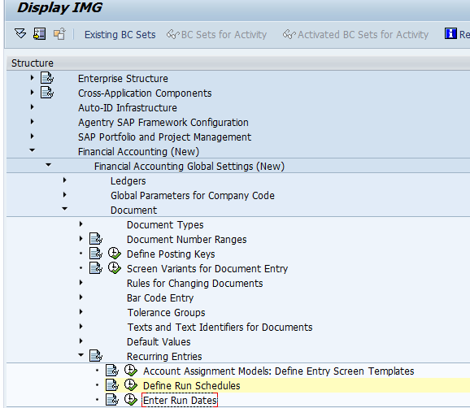

Note: In this activity, you define the run schedules by specifying a key and a description.

In a second activity, you enter the required dates for each schedule.

2). **Enter Run Dates**.

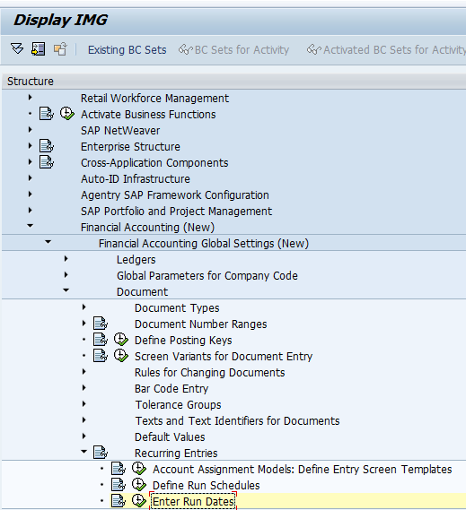

**ENDUSER ACTIVTIES**:

1). Creation of the Recurring Entry T.code-FBD1, Change-FBD2 and Display-FBD3.

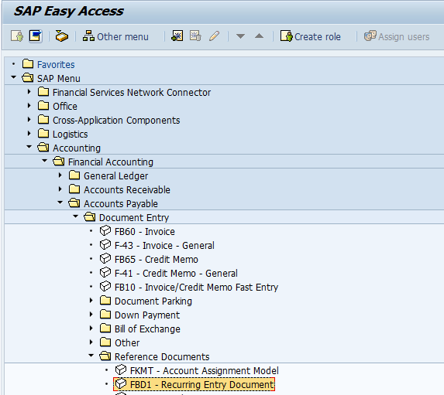

2).Create Accounting documents with reference Recurring Documents T.code-F.14.

3).Execution of the Batch input session T.code-SM35.

4). Recurring document List T.code F.15.

**Partial payment and Residual payment:**

Partial payment:

* Partial payment in SAP is a payment that is posted to an account without any open items being cleared.
* Before payment is made, 100 EUR is in open-item.

1).Dr. Expense 100 EUR

Cr. Vendor 100EUR<open-item>

2) F-59 (Payment request)

3).Then, I paid 75 USD from by bank account ( F110)

Dr. Vendor 75 EUR<open-item>

Cr. Bank 75EUR

* System shows that 75 EUR is paid as payment. Both 100 EUR and 75 EUR documents are in open item. It’s mean that you will see movement of transaction that 100 EUR still exist, 75 EUR is paid and 25 EUR is still to be paid.
* The remaining balance to be paid will be generated and 25 EUR (new document) will also be in open item until whole thing is cleared.

**Test scenario for automatic payment**

1. Vendor invoice posting T.code-F-43--1900000026
2. Partial payment T.code F-59 (Payment Request).
3. F110

**Manual partial payment**:

1. Vendor invoice posting T.code-F-43—1900000026
2. Manual outgoing payment F-53---1500000008

**Test scenario for Manual payment**

1. Vendor invoice posting T.code-F-43
2. Partial payment T.code F-53.

**Residual payment:-**

Residual item in SAP results when a payment is made for less than the actual amount outstanding.

The original open item is cleared and the system posts a new open item.

Before payment is made, 100 EUR is in open-item.

1).Dr. Expense 100 EUR—F-43/FB60/MIRO.

Cr. Vendor 100EUR<open-item>→ will be cleared with payment document

Then, I paid 75 EUR from by bank account.

2).Dr. Vendor 100 EUR<cleared>---F-53

Cr. Vendor 25 EUR<open-item>

Cr. Bank 75 USD

**Manual residual payment**:

1. Vendor invoice posting T.code-F-43—1900000026.
2. Manual outgoing payment F-53---1500000010 (Residual tab)

Note: F-59 is not applicable for residual payment.

* The original outstanding document for 100 eur is automatically cleared by the system when payment of 75 EUR is done. A new document will be generated as open for 25 EUR.
* Here we cannot trance the original outstanding as it will be shown as cleared though we have not cleared entire 100 EUR. This gives a picture that we have cleared 100 EUR which in incorrect as we have just paid 75 EUR.
* Hence in many companies partial is preferred as it shows the original outstanding, partial payment made along with the balance amount to be paid.

**Test scenario for Manual payment**

1. Vendor invoice posting T.code-F-43
2. Partial payment T.code F-53.

**If vendor is a customer and customer is vendor settings in SAP:**

1).Example: LG tv/mobile-Pune--SAP

2).Customer: LG DELAERS- All the locations--SAP

3)End customer: ABC/RAMA

1. In vendor master data (FK02/XK02) assign customer number vice versa.

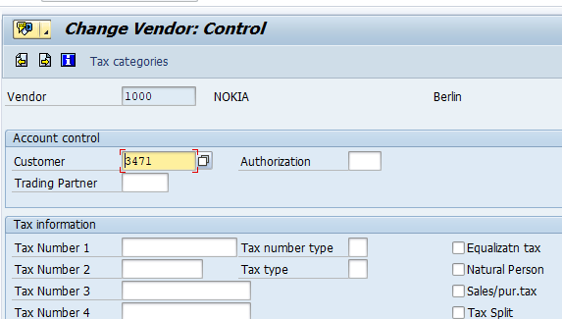

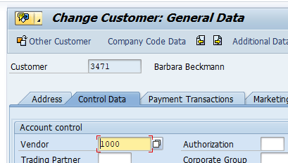

1. Select clearing with customer check in the vendor master data vice versa.

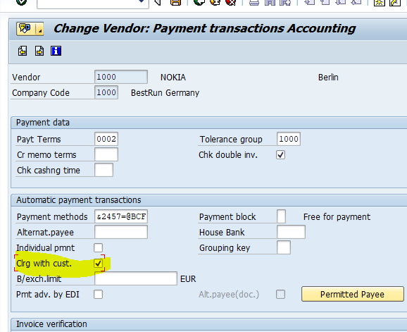

Test scenario-

1). Transaction postings T.code-F-43/FB60 and F-22 and FB70

2). Execution of the FBL1N with customer item AND FBL5N with vendor check.

